Import Libraries
import pandas as pd
import matplotlib.pyplot as plt
import seaborn as sns
import warnings
warnings.filterwarnings('ignore')

Loading dataset
df=pd.read_csv('Hotel_bookings_CSV.csv')

EDA and Cleaning
df.head()
hotel is_canceled lead_time arrival_date_year arrival_date_month \
0 Resort Hotel 0 342 2015 July
1 Resort Hotel 0 737 2015 July
2 Resort Hotel 0 7 2015 July
3 Resort Hotel 0 13 2015 July
4 Resort Hotel 0 14 2015 July
arrival_date_week_number arrival_date_day_of_month \
0 27 1
1 27 1
2 27 1
3 27 1
4 27 1
stays_in_weekend_nights stays_in_week_nights adults ... deposit_type \
0 0 0 2 ... No Deposit
1 0 0 2 ... No Deposit
2 0 1 1 ... No Deposit
3 0 1 1 ... No Deposit
4 0 2 2 ... No Deposit
agent company days_in_waiting_list customer_type adr \
0 NaN NaN 0 Transient 0.0
1 NaN NaN 0 Transient 0.0
2 NaN NaN 0 Transient 75.0
3 304.0 NaN 0 Transient 75.0
4 240.0 NaN 0 Transient 98.0
required_car_parking_spaces total_of_special_requests reservation_status \
0 0 0 Check-Out
1 0 0 Check-Out
2 0 0 Check-Out
3 0 0 Check-Out
4 0 1 Check-Out
reservation_status_date
0 1/7/2015
1 1/7/2015
2 2/7/2015
3 2/7/2015
4 3/7/2015
[5 rows x 32 columns]
df.tail()
hotel is_canceled lead_time arrival_date_year \
119385 City Hotel 0 23 2017
119386 City Hotel 0 102 2017
119387 City Hotel 0 34 2017
119388 City Hotel 0 109 2017
119389 City Hotel 0 205 2017
arrival_date_month arrival_date_week_number \
119385 August 35
119386 August 35
119387 August 35
119388 August 35
119389 August 35
arrival_date_day_of_month stays_in_weekend_nights \
119385 30 2
119386 31 2
119387 31 2
119388 31 2
119389 29 2
stays_in_week_nights adults ... deposit_type agent company \
119385 5 2 ... No Deposit 394.0 NaN
119386 5 3 ... No Deposit 9.0 NaN
119387 5 2 ... No Deposit 9.0 NaN
119388 5 2 ... No Deposit 89.0 NaN
119389 7 2 ... No Deposit 9.0 NaN
days_in_waiting_list customer_type adr \
119385 0 Transient 96.14
119386 0 Transient 225.43
119387 0 Transient 157.71
119388 0 Transient 104.40
119389 0 Transient 151.20
required_car_parking_spaces total_of_special_requests \
119385 0 0
119386 0 2
119387 0 4
119388 0 0
119389 0 2
reservation_status reservation_status_date
119385 Check-Out 6/9/2017
119386 Check-Out 7/9/2017
119387 Check-Out 7/9/2017
119388 Check-Out 7/9/2017
119389 Check-Out 7/9/2017
[5 rows x 32 columns]
df.shape
(119390, 32)
df.columns
Index(['hotel', 'is_canceled', 'lead_time', 'arrival_date_year',
'arrival_date_month', 'arrival_date_week_number',
'arrival_date_day_of_month', 'stays_in_weekend_nights',
'stays_in_week_nights', 'adults', 'children', 'babies', 'meal',
'country', 'market_segment', 'distribution_channel',
'is_repeated_guest', 'previous_cancellations',
'previous_bookings_not_canceled', 'reserved_room_type',
'assigned_room_type', 'booking_changes', 'deposit_type', 'agent',
'company', 'days_in_waiting_list', 'customer_type', 'adr',
'required_car_parking_spaces', 'total_of_special_requests',
'reservation_status', 'reservation_status_date'],
dtype='object')
df.info()
<class 'pandas.core.frame.DataFrame'>
RangeIndex: 119390 entries, 0 to 119389
Data columns (total 32 columns):
# Column Non-Null Count Dtype
--- ------ -------------- -----
0 hotel 119390 non-null object
1 is_canceled 119390 non-null int64
2 lead_time 119390 non-null int64
3 arrival_date_year 119390 non-null int64
4 arrival_date_month 119390 non-null object
5 arrival_date_week_number 119390 non-null int64
6 arrival_date_day_of_month 119390 non-null int64
7 stays_in_weekend_nights 119390 non-null int64
8 stays_in_week_nights 119390 non-null int64
9 adults 119390 non-null int64
10 children 119386 non-null float64
11 babies 119390 non-null int64
12 meal 119390 non-null object
13 country 118902 non-null object
14 market_segment 119390 non-null object
15 distribution_channel 119390 non-null object
16 is_repeated_guest 119390 non-null int64
17 previous_cancellations 119390 non-null int64
18 previous_bookings_not_canceled 119390 non-null int64
19 reserved_room_type 119390 non-null object
20 assigned_room_type 119390 non-null object
21 booking_changes 119390 non-null int64
22 deposit_type 119390 non-null object
23 agent 103050 non-null float64
24 company 6797 non-null float64
25 days_in_waiting_list 119390 non-null int64
26 customer_type 119390 non-null object
27 adr 119390 non-null float64
28 required_car_parking_spaces 119390 non-null int64
29 total_of_special_requests 119390 non-null int64
30 reservation_status 119390 non-null object
31 reservation_status_date 119390 non-null object
dtypes: float64(4), int64(16), object(12)
memory usage: 29.1+ MB
df['reservation_status_date'] = pd.to_datetime(df['reservation_status_date'])
df.describe(include = 'object')
hotel arrival_date_month meal country market_segment \
count 119390 119390 119390 118902 119390
unique 2 12 5 177 8
top City Hotel August BB PRT Online TA
freq 79330 13877 92310 48590 56477
distribution_channel reserved_room_type assigned_room_type \
count 119390 119390 119390
unique 5 10 12
top TA/TO A A
freq 97870 85994 74053
deposit_type customer_type reservation_status
count 119390 119390 119390
unique 3 4 3
top No Deposit Transient Check-Out
freq 104641 89613 75166
for col in df.describe(include = 'object').columns:
print(col)
print(df[col].unique())
print('-'*50)
hotel
['Resort Hotel' 'City Hotel']
--------------------------------------------------
arrival_date_month
['July' 'August' 'September' 'October' 'November' 'December' 'January'
'February' 'March' 'April' 'May' 'June']
--------------------------------------------------
meal
['BB' 'FB' 'HB' 'SC' 'Undefined']
--------------------------------------------------
country
['PRT' 'GBR' 'USA' 'ESP' 'IRL' 'FRA' nan 'ROU' 'NOR' 'OMN' 'ARG' 'POL'
'DEU' 'BEL' 'CHE' 'CN' 'GRC' 'ITA' 'NLD' 'DNK' 'RUS' 'SWE' 'AUS' 'EST'
'CZE' 'BRA' 'FIN' 'MOZ' 'BWA' 'LUX' 'SVN' 'ALB' 'IND' 'CHN' 'MEX' 'MAR'
'UKR' 'SMR' 'LVA' 'PRI' 'SRB' 'CHL' 'AUT' 'BLR' 'LTU' 'TUR' 'ZAF' 'AGO'
'ISR' 'CYM' 'ZMB' 'CPV' 'ZWE' 'DZA' 'KOR' 'CRI' 'HUN' 'ARE' 'TUN' 'JAM'
'HRV' 'HKG' 'IRN' 'GEO' 'AND' 'GIB' 'URY' 'JEY' 'CAF' 'CYP' 'COL' 'GGY'
'KWT' 'NGA' 'MDV' 'VEN' 'SVK' 'FJI' 'KAZ' 'PAK' 'IDN' 'LBN' 'PHL' 'SEN'
'SYC' 'AZE' 'BHR' 'NZL' 'THA' 'DOM' 'MKD' 'MYS' 'ARM' 'JPN' 'LKA' 'CUB'
'CMR' 'BIH' 'MUS' 'COM' 'SUR' 'UGA' 'BGR' 'CIV' 'JOR' 'SYR' 'SGP' 'BDI'
'SAU' 'VNM' 'PLW' 'QAT' 'EGY' 'PER' 'MLT' 'MWI' 'ECU' 'MDG' 'ISL' 'UZB'
'NPL' 'BHS' 'MAC' 'TGO' 'TWN' 'DJI' 'STP' 'KNA' 'ETH' 'IRQ' 'HND' 'RWA'
'KHM' 'MCO' 'BGD' 'IMN' 'TJK' 'NIC' 'BEN' 'VGB' 'TZA' 'GAB' 'GHA' 'TMP'
'GLP' 'KEN' 'LIE' 'GNB' 'MNE' 'UMI' 'MYT' 'FRO' 'MMR' 'PAN' 'BFA' 'LBY'
'MLI' 'NAM' 'BOL' 'PRY' 'BRB' 'ABW' 'AIA' 'SLV' 'DMA' 'PYF' 'GUY' 'LCA'
'ATA' 'GTM' 'ASM' 'MRT' 'NCL' 'KIR' 'SDN' 'ATF' 'SLE' 'LAO']
--------------------------------------------------
market_segment
['Direct' 'Corporate' 'Online TA' 'Offline TA/TO' 'Complementary' 'Groups'
'Undefined' 'Aviation']
--------------------------------------------------
distribution_channel
['Direct' 'Corporate' 'TA/TO' 'Undefined' 'GDS']
--------------------------------------------------
reserved_room_type
['C' 'A' 'D' 'E' 'G' 'F' 'H' 'L' 'P' 'B']
--------------------------------------------------
assigned_room_type
['C' 'A' 'D' 'E' 'G' 'F' 'I' 'B' 'H' 'P' 'L' 'K']
--------------------------------------------------
deposit_type
['No Deposit' 'Refundable' 'Non Refund']
--------------------------------------------------
customer_type
['Transient' 'Contract' 'Transient-Party' 'Group']
--------------------------------------------------
reservation_status
['Check-Out' 'Canceled' 'No-Show']
--------------------------------------------------
df.isnull().sum()
hotel 0
is_canceled 0
lead_time 0
arrival_date_year 0
arrival_date_month 0
arrival_date_week_number 0
arrival_date_day_of_month 0
stays_in_weekend_nights 0
stays_in_week_nights 0
adults 0
children 4
babies 0
meal 0
country 488
market_segment 0
distribution_channel 0
is_repeated_guest 0
previous_cancellations 0
previous_bookings_not_canceled 0
reserved_room_type 0
assigned_room_type 0
booking_changes 0
deposit_type 0
agent 16340
company 112593
days_in_waiting_list 0
customer_type 0
adr 0
required_car_parking_spaces 0
total_of_special_requests 0
reservation_status 0
reservation_status_date 0
dtype: int64
df.drop(['company' , 'agent'], axis = 1, inplace = True)
df.dropna(inplace = True)
df.isnull().sum()
hotel 0
is_canceled 0
lead_time 0
arrival_date_year 0
arrival_date_month 0
arrival_date_week_number 0
arrival_date_day_of_month 0
stays_in_weekend_nights 0
stays_in_week_nights 0
adults 0
children 0
babies 0
meal 0
country 0
market_segment 0
distribution_channel 0
is_repeated_guest 0
previous_cancellations 0
previous_bookings_not_canceled 0
reserved_room_type 0
assigned_room_type 0
booking_changes 0
deposit_type 0
days_in_waiting_list 0
customer_type 0
adr 0
required_car_parking_spaces 0
total_of_special_requests 0
reservation_status 0
reservation_status_date 0
dtype: int64
df.describe()
is_canceled lead_time arrival_date_year \
count 118898.000000 118898.000000 118898.000000
mean 0.371352 104.311435 2016.157656
std 0.483168 106.903309 0.707459
min 0.000000 0.000000 2015.000000
25% 0.000000 18.000000 2016.000000
50% 0.000000 69.000000 2016.000000
75% 1.000000 161.000000 2017.000000
max 1.000000 737.000000 2017.000000
arrival_date_week_number arrival_date_day_of_month \
count 118898.000000 118898.000000
mean 27.166555 15.800880
std 13.589971 8.780324
min 1.000000 1.000000
25% 16.000000 8.000000
50% 28.000000 16.000000
75% 38.000000 23.000000
max 53.000000 31.000000
stays_in_weekend_nights stays_in_week_nights adults \
count 118898.000000 118898.000000 118898.000000
mean 0.928897 2.502145 1.858391
std 0.996216 1.900168 0.578576
min 0.000000 0.000000 0.000000
25% 0.000000 1.000000 2.000000
50% 1.000000 2.000000 2.000000
75% 2.000000 3.000000 2.000000
max 16.000000 41.000000 55.000000
children babies is_repeated_guest \
count 118898.000000 118898.000000 118898.000000
mean 0.104207 0.007948 0.032011
std 0.399172 0.097380 0.176029
min 0.000000 0.000000 0.000000
25% 0.000000 0.000000 0.000000
50% 0.000000 0.000000 0.000000
75% 0.000000 0.000000 0.000000
max 10.000000 10.000000 1.000000
previous_cancellations previous_bookings_not_canceled \
count 118898.000000 118898.000000
mean 0.087142 0.131634
std 0.845869 1.484672
min 0.000000 0.000000
25% 0.000000 0.000000
50% 0.000000 0.000000
75% 0.000000 0.000000
max 26.000000 72.000000
booking_changes days_in_waiting_list adr \
count 118898.000000 118898.000000 118898.000000
mean 0.221181 2.330754 102.003243
std 0.652785 17.630452 50.485862
min 0.000000 0.000000 -6.380000
25% 0.000000 0.000000 70.000000
50% 0.000000 0.000000 95.000000
75% 0.000000 0.000000 126.000000
max 21.000000 391.000000 5400.000000
required_car_parking_spaces total_of_special_requests
count 118898.000000 118898.000000
mean 0.061885 0.571683
std 0.244172 0.792678
min 0.000000 0.000000
25% 0.000000 0.000000
50% 0.000000 0.000000
75% 0.000000 1.000000
max 8.000000 5.000000
df = df[df['adr']<5000]

Data Analysis and Visualization
cancelled_perc = df[ 'is_canceled'].value_counts(normalize = True)
print(cancelled_perc)
plt.figure(figsize = (5,4))
plt.title('Reservation status count')
plt.bar(['Not canceled','Canceled'],df['is_canceled'].value_counts(), edgecolor = 'y' , width = 0.7)
plt.show()
0 0.628653
1 0.371347
Name: is_canceled, dtype: float64
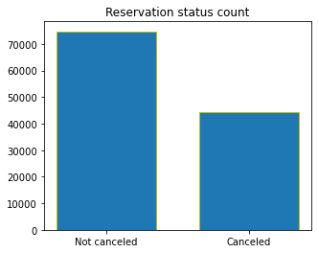
plt.figure(figsize = (8,4))
ax1 = sns.countplot(x = 'hotel', hue = 'is_canceled', data = df, palette = 'Blues')
legend_labels,_ = ax1. get_legend_handles_labels()
ax1.legend(bbox_to_anchor=(1,1))
plt.title('Reservation status in different hotels', size = 20)
plt.xlabel('hotel')
plt.ylabel('number of reservations')
plt.show()
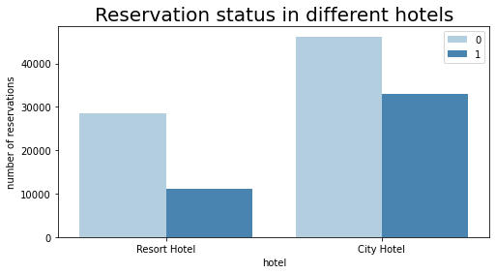
resort_hotel = df[df['hotel'] == 'Resort Hotel']
resort_hotel['is_canceled'].value_counts(normalize = True)
0 0.72025
1 0.27975
Name: is_canceled, dtype: float64
city_hotel = df[df['hotel'] == 'City Hotel']
city_hotel['is_canceled'].value_counts(normalize = True)
0 0.582918
1 0.417082
Name: is_canceled, dtype: float64
resort_hotel = resort_hotel.groupby('reservation_status_date')[['adr']].mean()
city_hotel = city_hotel.groupby('reservation_status_date')[['adr']].mean()
plt.figure(figsize = (20,8))
plt.title('Average Daily Rate in city and Resort Hotel', fontsize = 30)
plt.plot(resort_hotel.index, resort_hotel['adr'], label = 'Resort Hotel')
plt.plot(city_hotel.index, city_hotel['adr'], label = 'City Hotel')
plt.legend(fontsize = 20)
plt.show()
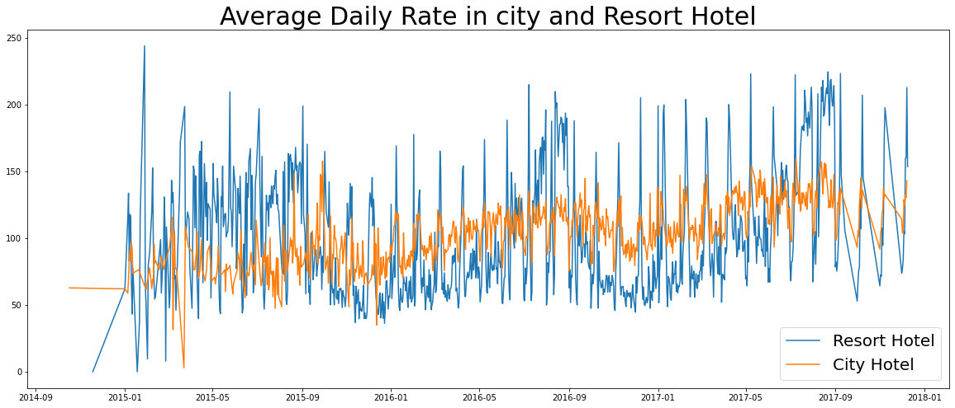
df['month'] = df['reservation_status_date'].dt.month
plt.figure(figsize = (16,8))
ax1 = sns.countplot(x = 'month', hue = 'is_canceled', data=df, palette = 'bright')
legend_labels,_ = ax1.get_legend_handles_labels()
ax1.legend(bbox_to_anchor = (1,1))
plt.title('Reservation status per month', size = 20)
plt.xlabel('month')
plt.ylabel('number of reservations')
plt.legend(['not canceled', 'canceled'])
plt.show()
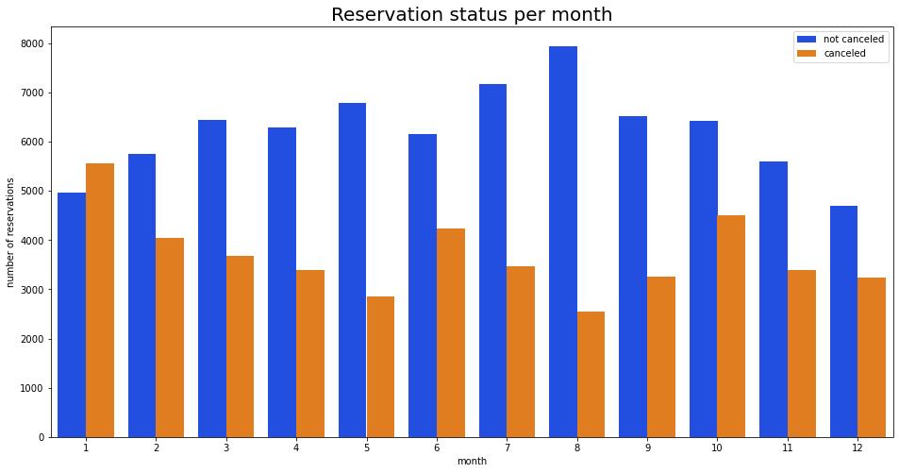
plt.figure(figsize = (15,8))
plt.title('ADR per month', fontsize = 30)
sns.barplot('month', 'adr', data = df[df['is_canceled'] == 1].groupby('month')[['adr']].sum().reset_index())
plt.show()
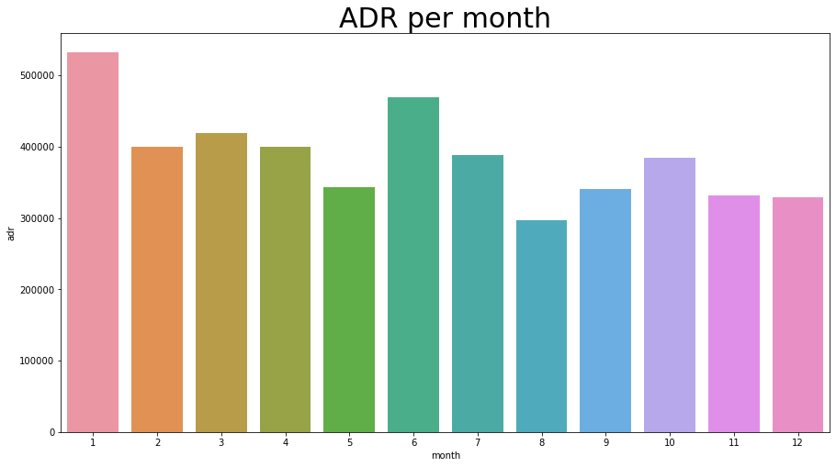
cancelled_data = df[df['is_canceled']==1]
top_10_country = cancelled_data['country'].value_counts()[:10]
plt.figure(figsize = (8,8))
plt.title('Top 10 countries with reservation canceled')
plt.pie(top_10_country, autopct = '%.2f', labels = top_10_country.index)
plt.show()
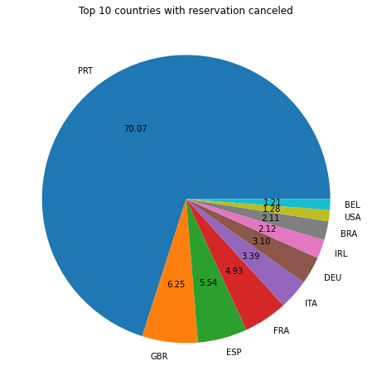
df['market_segment'].value_counts()
Online TA 56402
Offline TA/TO 24159
Groups 19806
Direct 12448
Corporate 5111
Complementary 734
Aviation 237
Name: market_segment, dtype: int64
df['market_segment'].value_counts(normalize = True)
Online TA 0.474377
Offline TA/TO 0.203193
Groups 0.166581
Direct 0.104696
Corporate 0.042987
Complementary 0.006173
Aviation 0.001993
Name: market_segment, dtype: float64
cancelled_data['market_segment'].value_counts(normalize = True)
Online TA 0.469696
Groups 0.273985
Offline TA/TO 0.187466
Direct 0.043486
Corporate 0.022151
Complementary 0.002038
Aviation 0.001178
Name: market_segment, dtype: float64
cancelled_df_adr = cancelled_data.groupby('reservation_status_date')[['adr']].mean()
cancelled_df_adr.reset_index(inplace = True)
cancelled_df_adr.sort_values('reservation_status_date', inplace = True)
not_cancelled_data = df[df['is_canceled'] == 0]
not_cancelled_df_adr = not_cancelled_data.groupby('reservation_status_date')[['adr']].mean()
not_cancelled_df_adr.reset_index(inplace = True)
not_cancelled_df_adr.sort_values('reservation_status_date', inplace = True)
plt.figure(figsize = (20,6))
plt.title('Average Daily Rate')
plt.plot(not_cancelled_df_adr['reservation_status_date'],not_cancelled_df_adr['adr'], label = 'not cancelled')
plt.plot(cancelled_df_adr['reservation_status_date'],cancelled_df_adr['adr'], label = 'cancelled')
plt.legend(fontsize = 20)
plt.show()
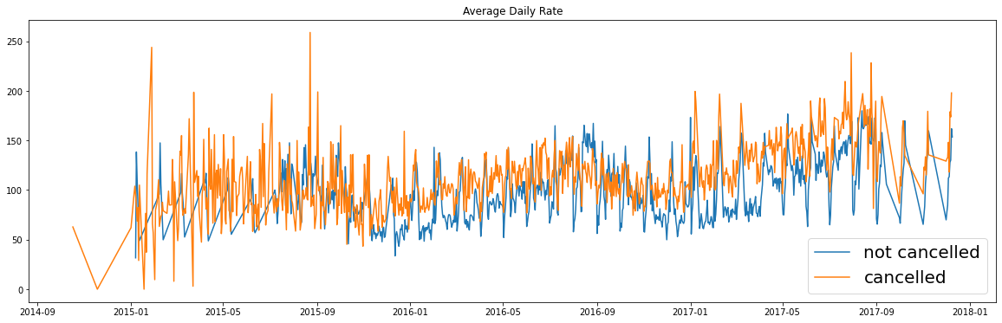
cancelled_df_adr = cancelled_df_adr[(cancelled_df_adr['reservation_status_date']>'2016') & (cancelled_df_adr['reservation_status_date']<'2017-09')]
not_cancelled_df_adr = not_cancelled_df_adr[(not_cancelled_df_adr['reservation_status_date']>'2016') & (not_cancelled_df_adr['reservation_status_date']<'2017-09')]
plt.figure(figsize = (20,6))
plt.title('Average Daily Rate')
plt.plot(not_cancelled_df_adr['reservation_status_date'],not_cancelled_df_adr['adr'], label = 'not cancelled')
plt.plot(cancelled_df_adr['reservation_status_date'],cancelled_df_adr['adr'], label = 'cancelled')
plt.legend(fontsize = 20)
plt.show()
